**Project Design Phase-II**

**Technology Stack (Architecture & Stack)**

|  |  |
| --- | --- |
| Date | 14 October 2022 |
| Team ID | PNT2022TMID44926 |
| Project Name | Smart farmer IOT Enabled Smart Farming Application |
| Maximum Marks | 4 Marks |

**Technical Architecture:**

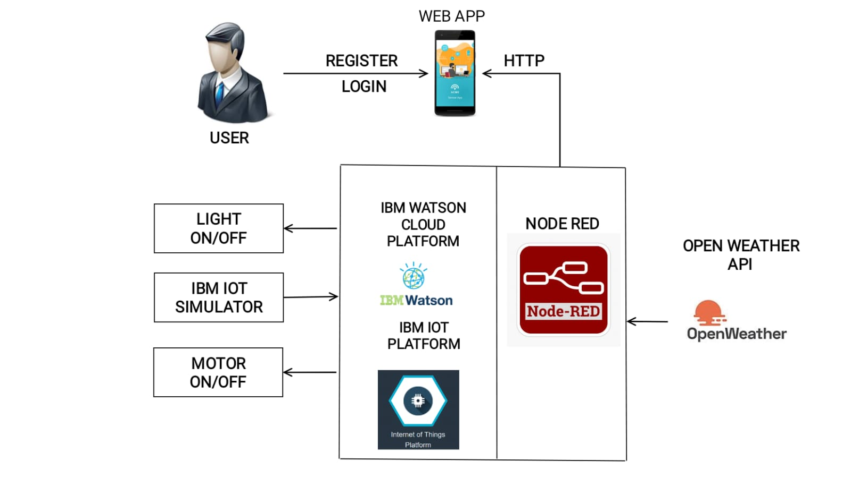

**Table-1 : Components & Technologies:**

|  |  |  |  |
| --- | --- | --- | --- |
| **S.No** | **Component** | **Description** | **Technology** |
|  | User Interface | Web App or Web UI, Android app | Python |
|  | Application Logic-1 | Registration process in the application | Python |
|  | Application Logic-2 | Login process in the application | IBM Watson STT service |
|  | Database | In the data base store the user’s data | NoSQL |
|  | Cloud Database | Database Service on Cloud using IBM Cloudant | IBM Cloudant |
|  | File Storage | File storage requirements to save the user data’s by using IBM Cloud storage | IBM Cloud Storage |
|  | External API-1 | The open weather API used to monitoring the weather conditions | Open Weather API. |
|  | External API-2 | Google Login API used to login to the application | Google Login API |
|  | Infrastructure ( Cloud) | Application Deployment on Cloud | Cloud Foundry |

**Table-2: Application Characteristics:**

| **S.No** | **Characteristics** | **Description** | **Technology** |
| --- | --- | --- | --- |
|  | Open-Source Frameworks | HTTP Server, Internet Browsers, | Andoid –Mobile phone platform |
|  | Security Implementations | Risk assessment , Limit user acess to data, Encrypt the data , Update and patch regularly | Encryptions, Updates regularly |
|  | Scalable Architecture | It supports higher workloads without any fundamental changes to it | Mit app Invertor |
|  | Availability | In this application have to check weather conditions, temperature , Humidity | Open weather API |
|  | Performance | Desighn consideration for the performance is for each request have 2 second to load the details in the application | Python |